
Technological University Dublin
Blanchardstown Campus

Bachelor of Engineering in Computer Engineering
H3024 Project 2

Project Title: RFID Pet Tagger

Author: James Divinagracia

Supervisor: Ivan Smyth, Fergus Maughan, Brian DeBrit

Date: 30/04/2026

Declaration

The material contained in this assignment is the author’s original work, except where work quoted is duly acknowledged in the text. No aspect of this assignment has been previously submitted in any other unit or course.

Signed:

Date: 30 /04/2026 .

Abstract
This is a 3rd year project report that consists of the author and student’s attempt of developing and synthesizing a self-guided project during the entire school year.

It is a portable IoT and RFID animal pet logging device that reads of a tag that reads a unique ID to be confirmed through a local database (inside the device itself), with the newly processed data being sent through a telemetry web app service which shows the time stamped event of which the pet daycare has delegated to a client’s pet.

Acknowledgements
I would like to thank my family and friends for assisting and supporting me throughout my three years of studying in this course, that whatever the future holds that I am aware of them being behind me.

I would like to thank my lecturers for the patience of teaching me; may they continue to be patient during my time on this course.

Table of Contents
Declaration ii
Abstract iii
Acknowledgements iii
Table of Contents iv
Abbreviations, Symbols, Acronyms v
List of Figure Captions vi
List of tables vi
No table of figures entries found. vi
Product Specifications vi
Executive Summary vi
1 Introduction 0
1.1 The Aim 0
1.2 Motivation 0
1.3 Project Objectives and Scope 0
2 Background Research 1
2.1 Instruction: Do not just list facts. Compare and contrast. 1
2.2 State of the Art: Research current academic papers or high-end industrial solutions related to your topic. 1
2.3 Comparative Analysis: Use a table to compare existing products or methods (e.g., cost, efficiency, complexity). 1
2.4 Component Selection: Justify your choices. Explain why you chose a specific microcontroller (e.g., ESP32 vs. STM32) or communication protocol over others researched during the year. 1
3 Project Design 2
3.1 System Architecture 2
3.2 Hardware Design 2
3.3 Software Design 6
3.4 Data Structures 6
3.5 Trade-off Analysis 6
4 Project Construction and Testing 7
4.1 Construction 7
4.2 Results and Analysis 7
5 Safety, Ethics, and Sustainability 8
5.1 Risk Assessment 8
5.2 Ethical Considerations 8
5.3 Sustainability 8
6 Conclusions and Recommendations 9
References 10
7 References 10
Appendix 12
Timetable 13

Abbreviations, Symbols, Acronyms
I²C – Inter-Integrated Circuit
LCD – Liquid Crystal Display
SPI – Serial Peripheral Interface
VCS – Version Control System
IDE – Integrated Development Environment
µC – Microcontroller
BMS – Battery Management System
IoT – Internet of Things
ESP-32 – ESP-32-S3-WROOM-V2
Li-ion – Lithium Ion

List of Figure Captions

Figure 1: Overall process block diagram 2

List of tables

No table of figures entries found.

Product Specifications

Executive Summary
Modern Society now rely on electronic devices as ever. This product solves a commercial problem of handling and logging items (in this case, pets), with a simple user interface that allows little to no training for newer employees.

Introduction

The Aim
The aim of this project is to design and create a fully functional pet tag reader/writer for commercial based pet daycare for airplane passengers. The device has the basic functionality of an IoT device which is to send and receive data from the cloud or web client.
It is also portable as it has a backup battery pack and BMS for outdoor use.
It has a display which can be interacted with buttons for menu switching for different functions.
The main µC will have sleep states which is essential for a mobile device.

Motivation
This module will be delving deeper in the IoT aspect regarding building a project, not only that, but we also get to choose our own project.
The simplicity of my RF tagging device in hardware and key parts allows me to focus on software robustness and complexity which I lack when finalising my 2nd year project.

I will be researching harder firmware topics such as graphical interfaces of small screen devices (GFX_Library) [1], handling external memory access using the Micro SD card read/write feature of the ESP32, conserving battery health by using ESP-32’s deep sleep function and rounding up information to the cloud with a specified timestamp.

Project Objectives and Scope
The attributes of this project are highlighted below:
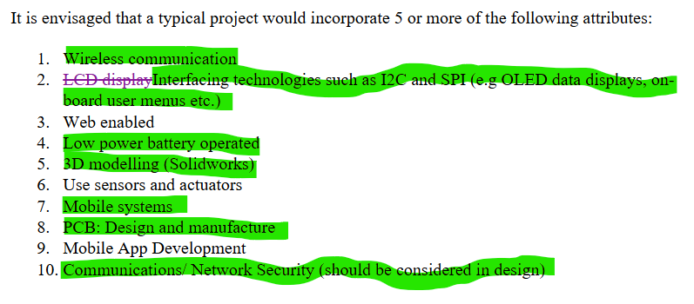

Background Research

Component Selection:

ESP32-S3:

Project Design

System Architecture
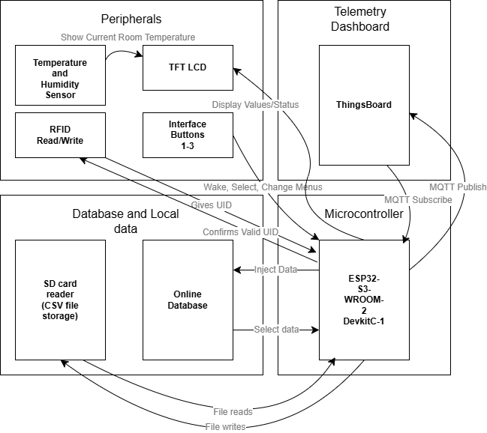
Figure 1: Overall process block diagram

Hardware Design

3.2.2 Initial Schematic Design

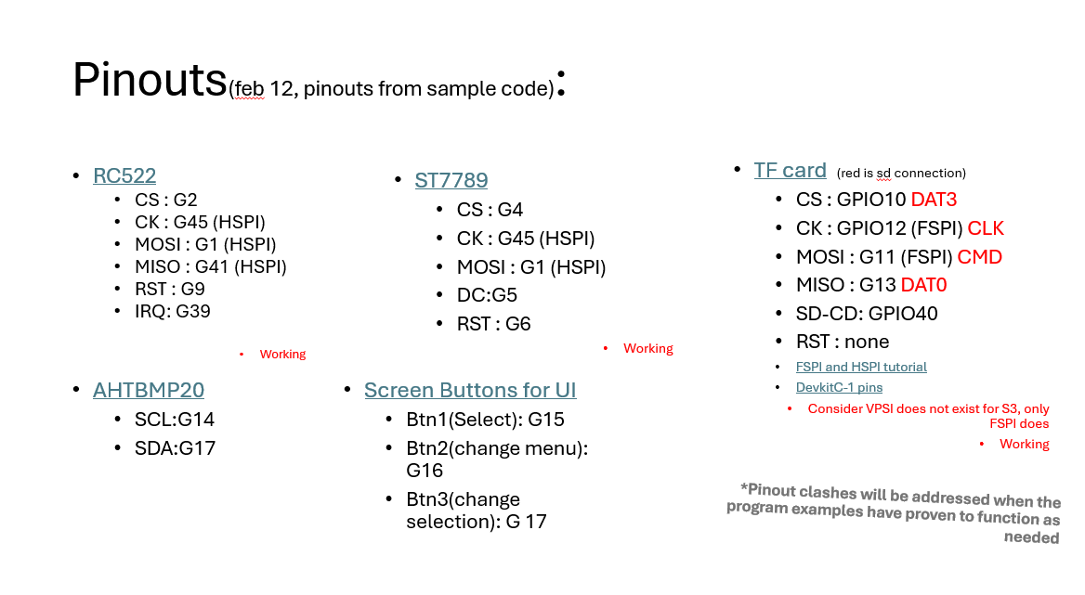
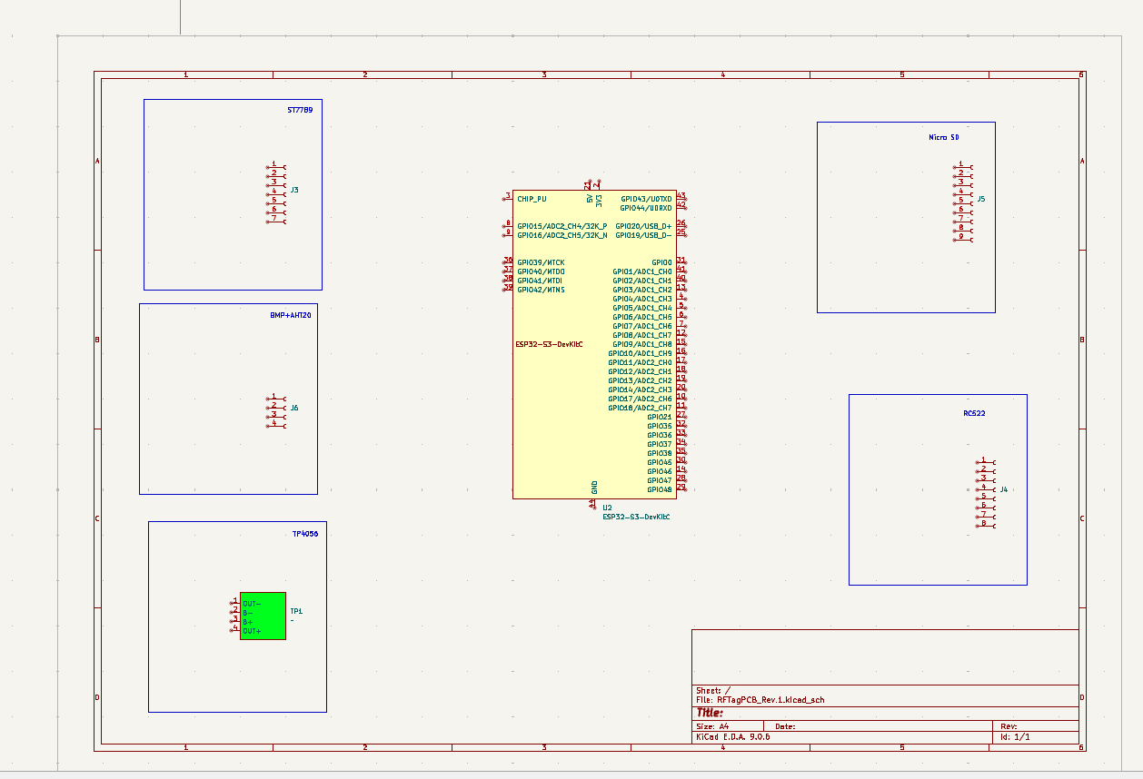

3.2.3 Final Schematic Design

The final Schematic Design is shown below at full size for clearer details:
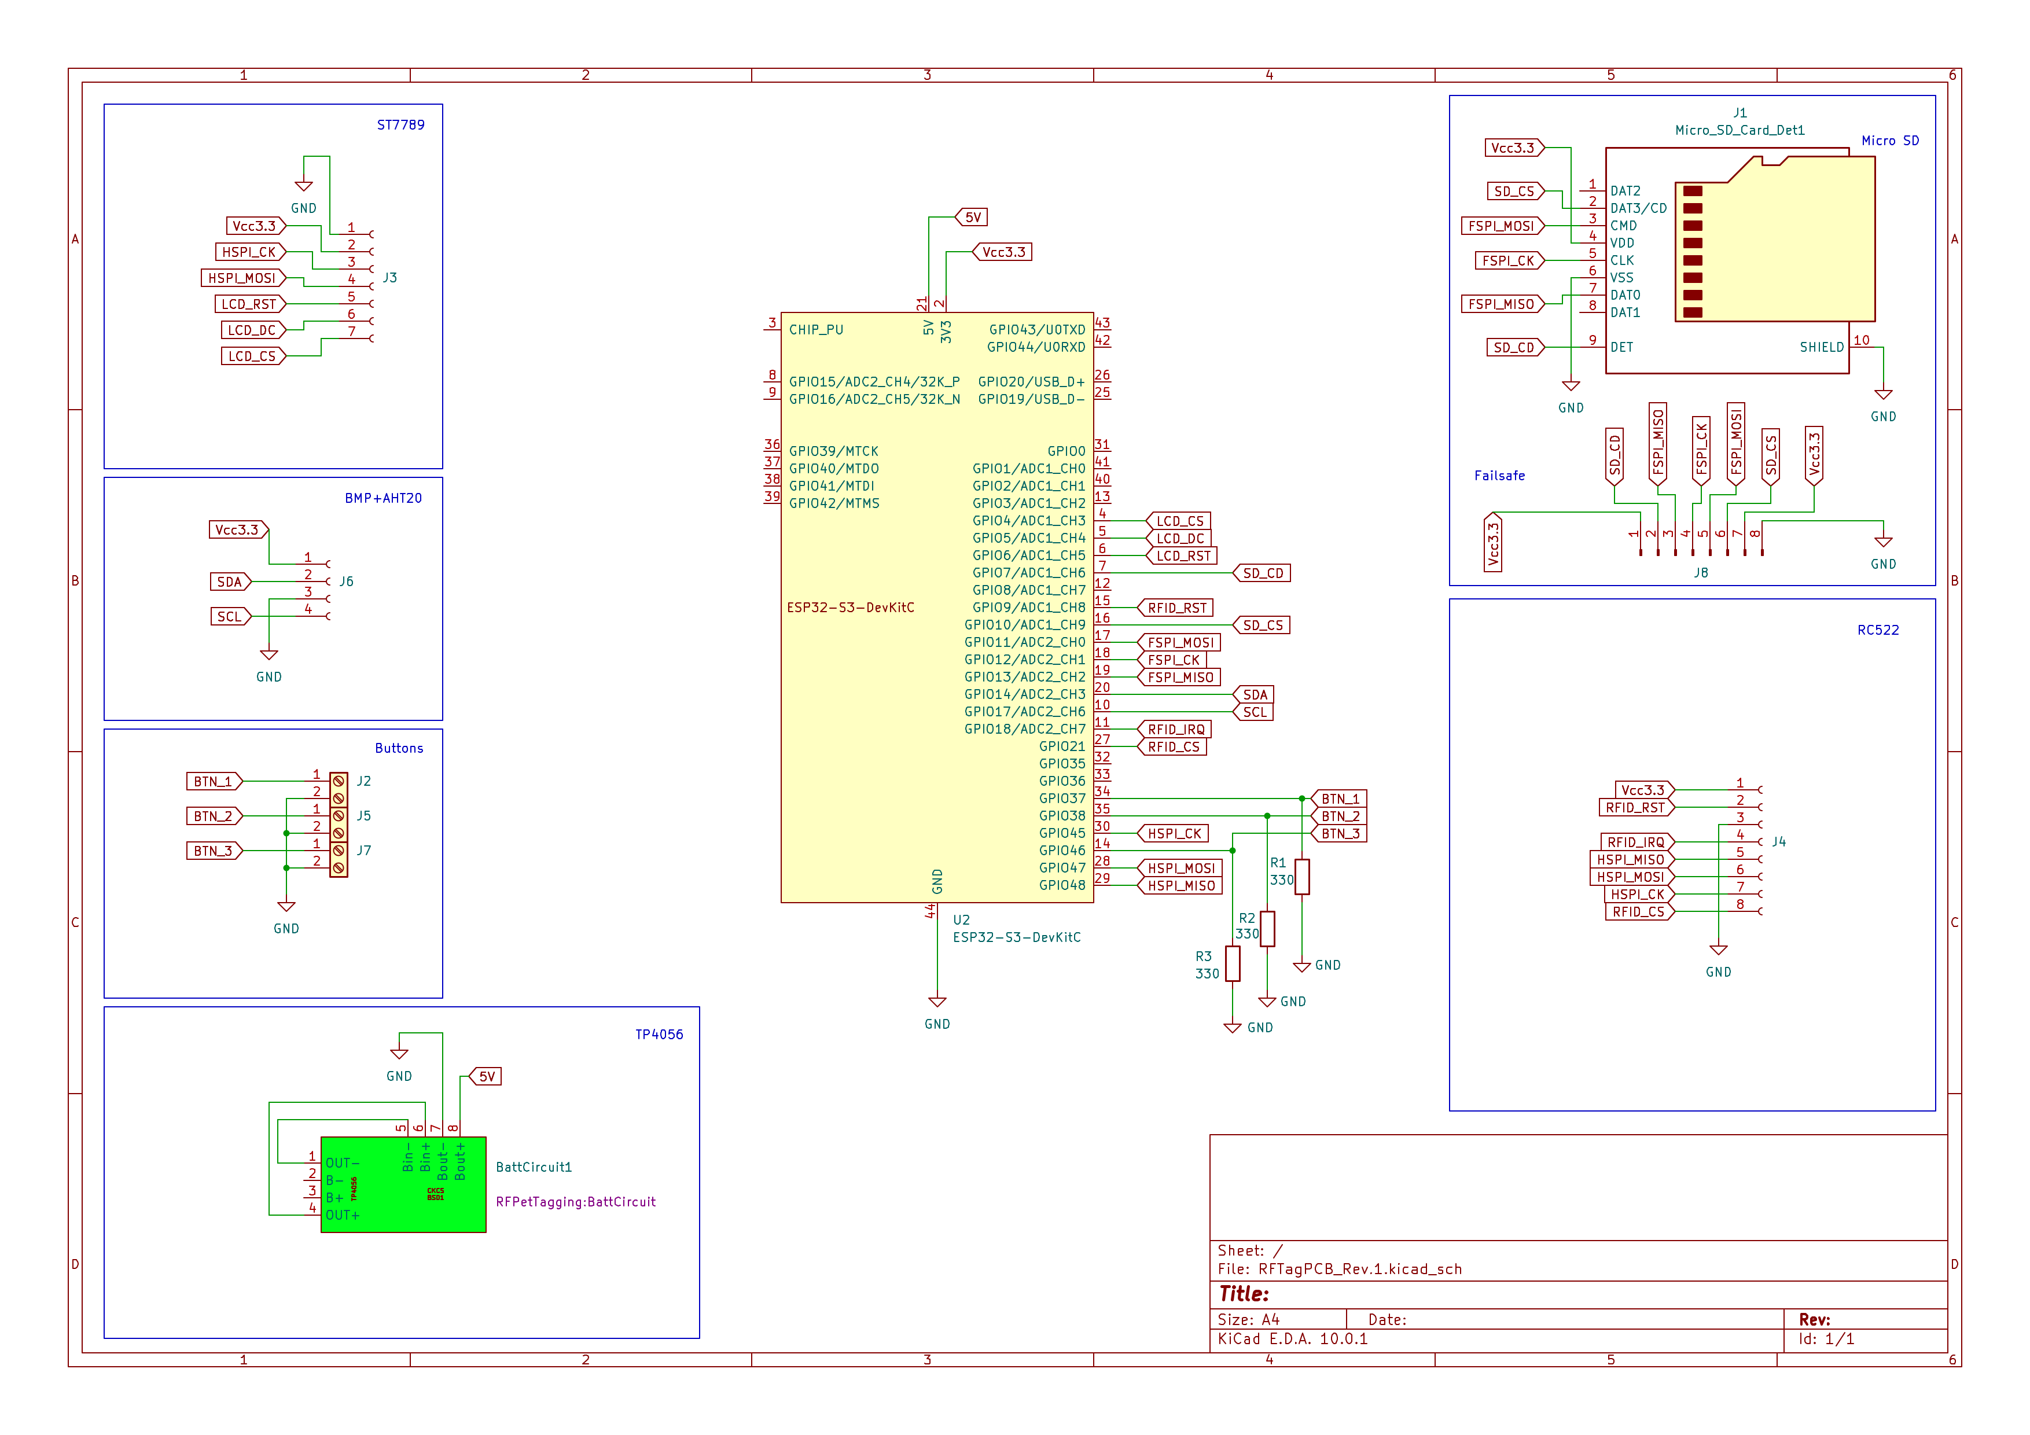
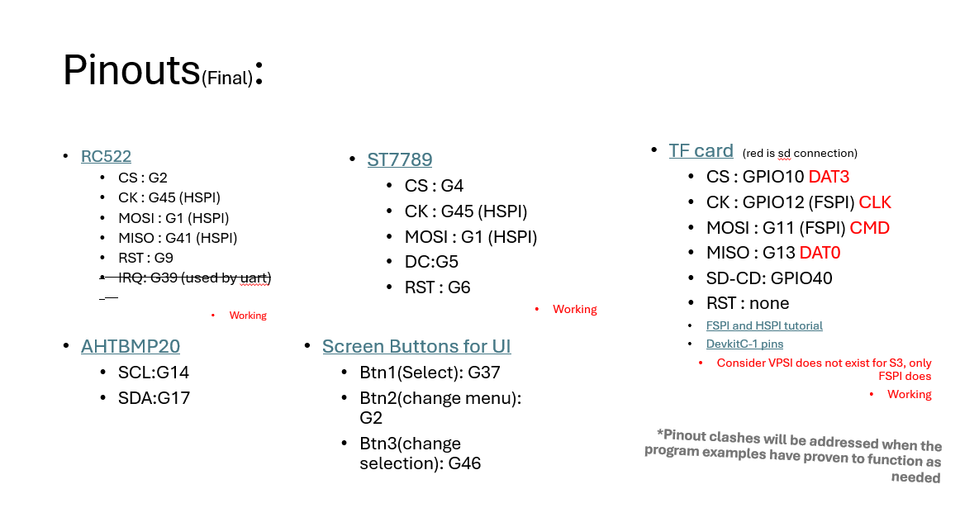

3.2.3.1 Custom Battery Charging Circuit Footprint + Symbol
KiCAD professionally allows you to create custom footprints and

Symbol:

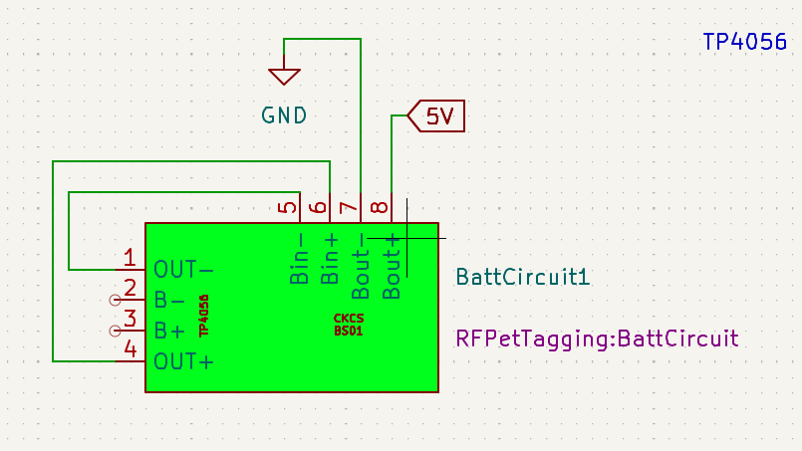
Footprint:
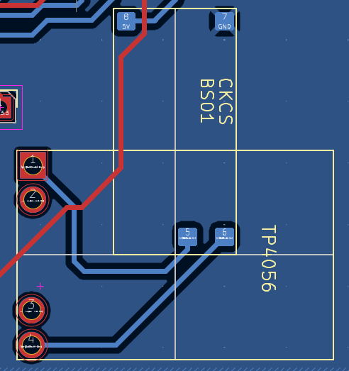

3.2.4 Initial Board Design
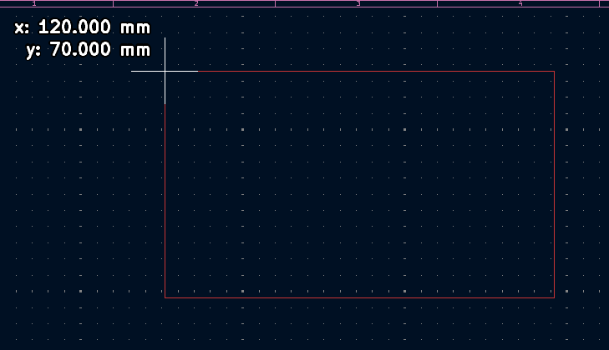

It is an unusually long PCB compared to how usual PCB design goes, but there is a reasoning for that (check construction).

3.2.5 Final Board Design

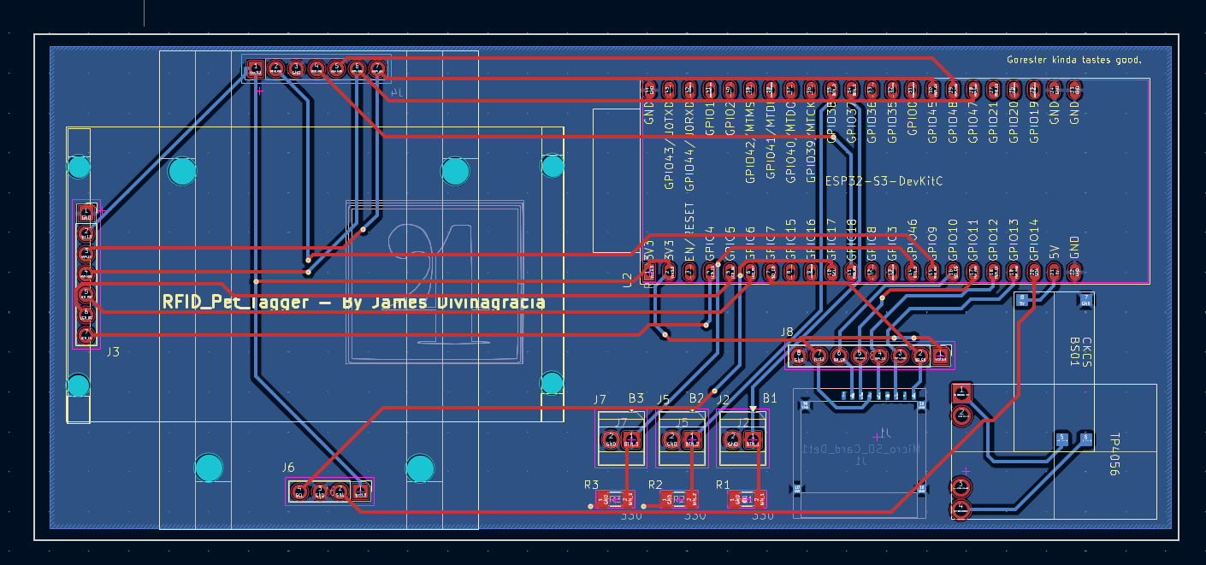

The final board dimensions are 143.5 * 63.5 in millimetres. It consists of sockets for an easier installation of circuit modules.
The mounting holes were also considered to secure the parts to the PCB, and for an easy installation to the chassis.

3.2.5.1 SMD soldered Micro SD

As a way to practice tiny surface mount component soldering, I decided to extract the micro SD card slot from the breakout board that one of my supervisors have given me, my reasoning is that not only there are no other passive components that are required by the component, it also reduces the space required to install the micro SD card. Latency matters for such a high-speed device, and so I concluded that it would be best if the component has minimal distance from the microcontroller.

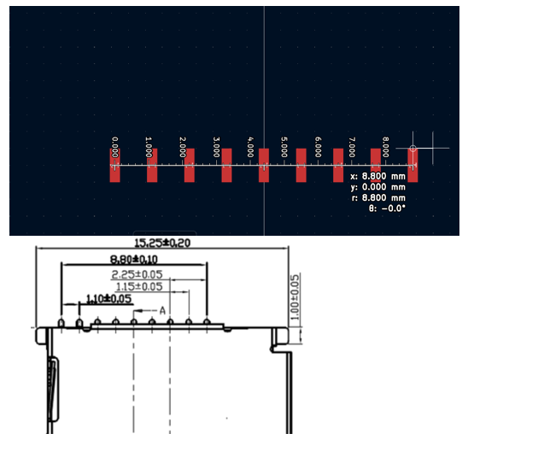

Software Design

The project contains aspects such as:

Data Structures
If applicable, explain how data is stored or processed (e.g., arrays, buffers, or specific algorithms).

Trade-off Analysis

The device AHT20 + BMP20 was not implemented at the end as it is a non-functional feature which is to show live temperature readings of the room to the LCD, this allows for a faster menu process.

Project Construction and Testing

Construction
This chapter includes project assembly with a huge focus on the 3D printed chassis that took a while to develop. Solder work patches and

Results and Analysis

Safety, Ethics, and Sustainability

Risk Assessment
Include a table identifying potential hazards (e.g., battery safety, high voltage) and your mitigation strategies.
Potential Hazards
Battery safety | The device is battery powered, which means there are considerations such as:  Overcharging or undercharging, improper charging, being structurally secured to the chassis.  The combination of TP4056 and CKCS BS01 in the circuit provides over-under charging concerns whilst the latter provide a clean and efficient supply of 5V which the ESP-32 requires.

Ethical Considerations
User (Owner) credentials are required to validate the pet’s status during their time on the daycare, which includes email, phone number and in most cases, their address. This increases the risk of stolen information that could be used for phishing or invasion of privacy. Possible solutions is to give the employees awareness that such devices needs to be used with care and to immediately report to the higher ups in an event of losing the device or it being stolen.

Sustainability
The device uses upcycled Li-ion batteries from vape batteries which has been used on single use recreational devices, this device, if mass produced can make use of the huge supply of disposed yet healthy battery cells.

Conclusions and Recommendations
My final product shows the essential structure and components needed for a IoT-based RFID item logging device; however further software considerations must be met.

References
Advanced Monolithic Systems. (n.d.). advanced-monolithic.com. Retrieved 12, from http://www.advanced-monolithic.com/pdf/ds1117.pdf
Burgess, P. (2025, 01 22). learn.adafruit.com. Retrieved 12 12, 2025, from https://learn.adafruit.com/adafruit-gfx-graphics-library
Dhaker, P. (2018, 09). analog.com. (Analog Devices) Retrieved 12 12, 2025, from https://www.analog.com/en/resources/analog-dialogue/articles/introduction-to-spi-interface.html
Docker Inc. (2025). Docker. (Docker) Retrieved 12 12, 2025, from https://www.docker.com/
Espressif Systems. (2025). espressif.com. Retrieved 12 12, 2025, from https://www.espressif.com/sites/default/files/documentation/esp32-s3-wroom-2_datasheet_en.pdf
FreeRTOS. (2024). https://www.freertos.org/. Retrieved 12 12, 2025, from https://www.freertos.org/
FreeRTOS. (2025, 11). freertos.org. Retrieved 12 12, 2025, from https://www.freertos.org/Documentation/02-Kernel/04-API-references/10-Semaphore-and-Mutexes/00-Semaphores
MQTT. (2024). mqtt.org. (MQTT) Retrieved 12 12, 2025, from https://mqtt.org/
The Thingsboard Authors. (2025). https://thingsboard.io/. (Thingsboard) Retrieved 12 12, 2025, from https://thingsboard.io/

Appendix

Specification sheets for components, software code, AutoCAD drawing, Etc

NO PADDING
Padding is where you add in data sheets for components which are standard and do not need to be included such as a common transistor type. It can also be the inclusion of 20 pages of a data sheet when only 4 of them are relevant.
Quantity does not necessarily mean quality.

Circuit Diagrams from Eagle, MultiSim, CadStar etc.

Include proper block diagrams and circuit diagrams. NO SCREEN DUMPS FROM ECAD.
Add in the printed diagrams in your report at the end or print to a PDF file and include it in the soft copy of your report.

Timetable

Include here the timetable you used for Project 1 and your timetable for Project 2 in tabular form.

